Keywords for google search: **Persistent memory bootable ubuntu USB in Windows**

## My system properties:

* 8GB RAM
* 32 GB USB pendrive
* Windows 10 HP laptop
* intel i5-5200 processor
* Will use Ubuntu 16.04
* Will use Kinetic Kame ROS

## Formatting a USB

**In Windows 10**

1. Take a Pendrive with a large enough space (>4GB) [I used 32 GB.]
2. Open command by typing **cmd** in Windows search bar.
3. Type **diskpart**

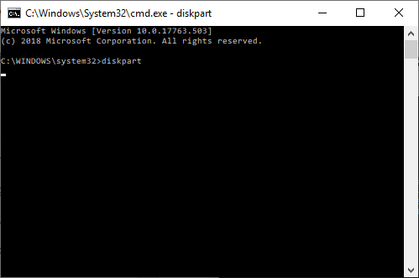

* 1. If a prompt asks for permission Click ***allow***

1. A new window opens. It is diskpart.   
   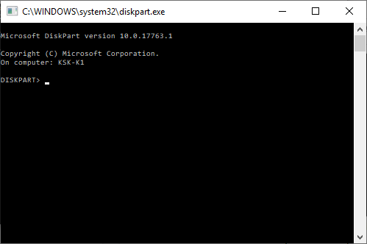
2. Type *list disk*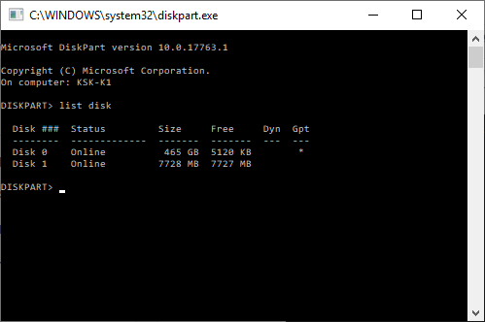  
   You can see the USB as the 7728MB disk: Disk 1
3. Type *select disk 1*
4. Type *clean*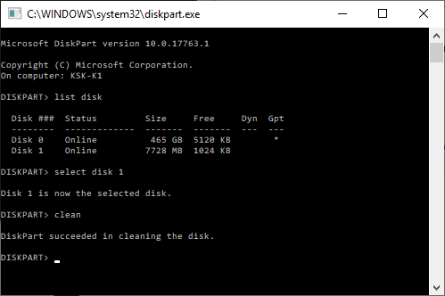
5. The USB is now foratted and clean
6. Close *diskpart* and *cmd*

#### To setup USB for NTFS architecture

1. Open Disk partition manager  
   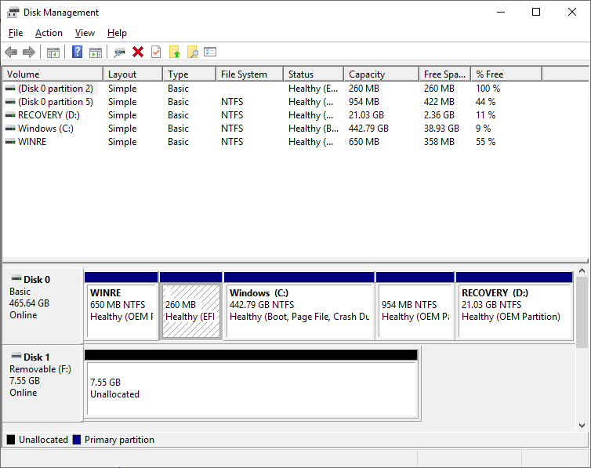
2. Right click the 7.55GB Unallocated part and click ‘New Simple Volume’  
   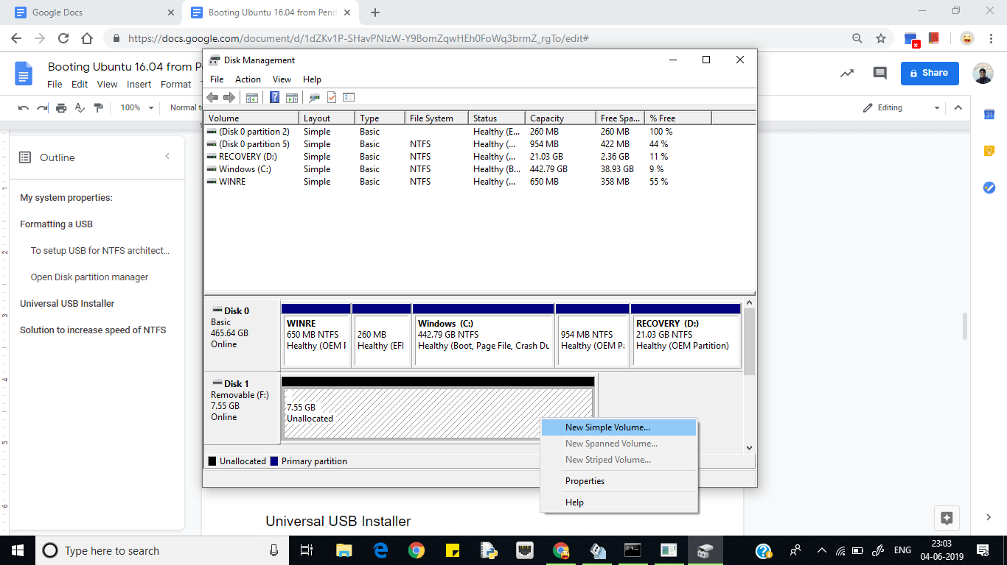
3. 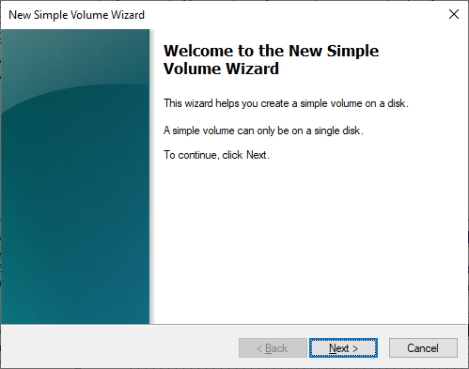
4. 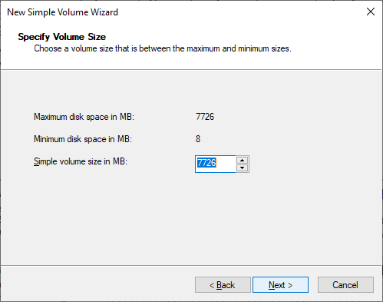
5. 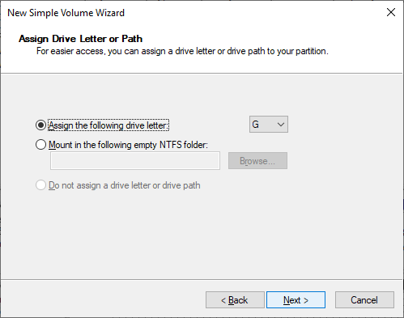
6. 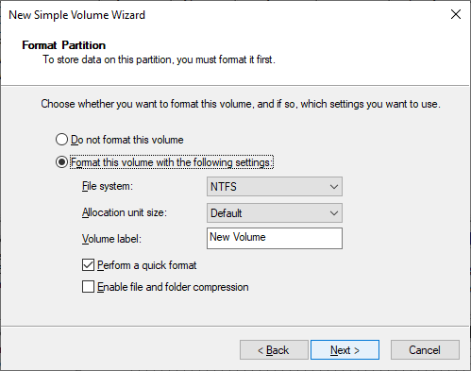  
   Ensure thet the File system is chosen as **NTFS**
7. 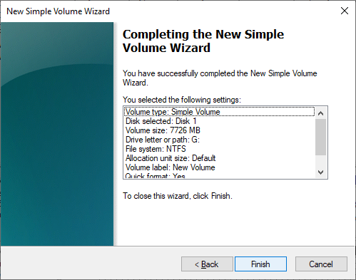
8. Click finish
9. 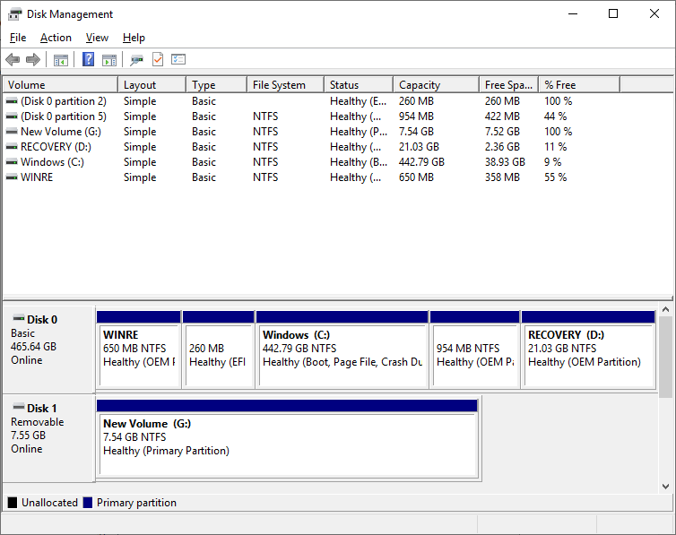  
   Now the USB is in NTFS architecture

## Universal USB Installer

1. Download Ubuntu 16.04 .iso file from Ubuntu website.
2. Go to pendrive linux website and download the their software: universal USB installer.

Some links with instuctions

* 1. <https://tecadmin.net/create-ubuntu-bootable-usb-in-windows/>

1. Click I Agree

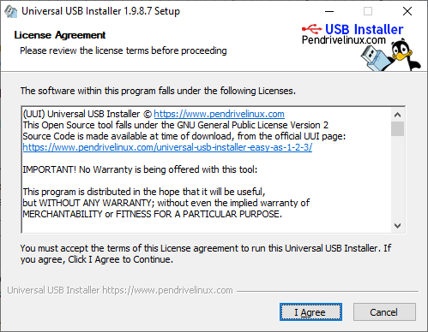

1. Choose Ubuntu

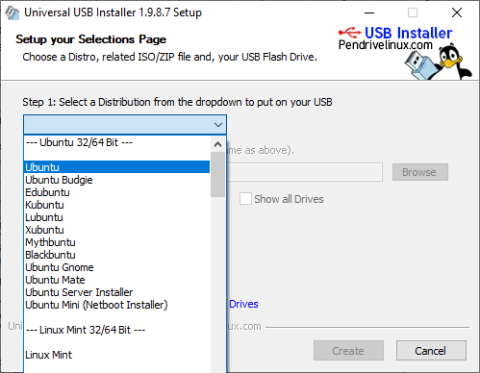

1. Next, Click **Browse** and choose the Ubuntu 16.04 / 18.04 **.iso file**.
2. FAT32 architecture will make casper-rw files of **only upto 4GB**. (casper-rw is the place where the memory is stored- persistent memory)
3. I took NTFS architecture in universal USB installer (this allows bigger casper-rw file size **upto 16 exabytes!**)
4. Wait for it to complete.
5. NTFS will normally work very slowly as compared to FAT32 in a bootable Ubuntu USB.

## Solution to increase speed of NTFS

1. Go to Boot Manager.
   1. In my HP laptop, clicking restart while pressing the shift button will take me to this page  
      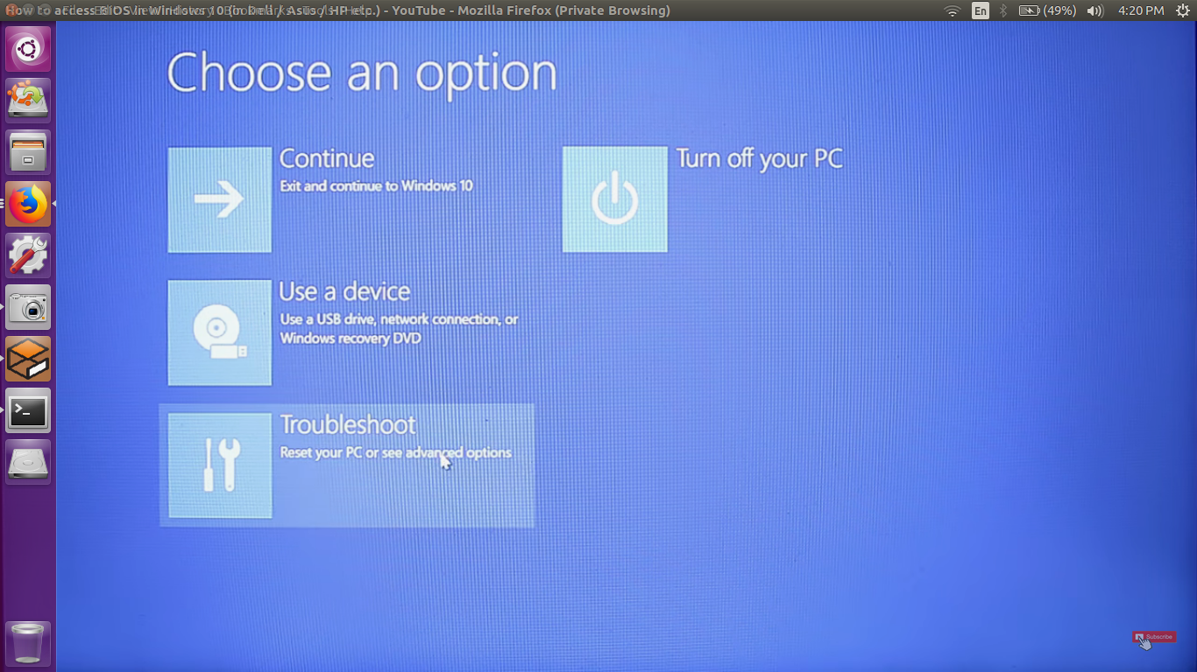
      1. Click troubleshoot and choose advanced options.
      2. Choose UEFI firmware settings and finally click restart.
   2. This is the Boot manager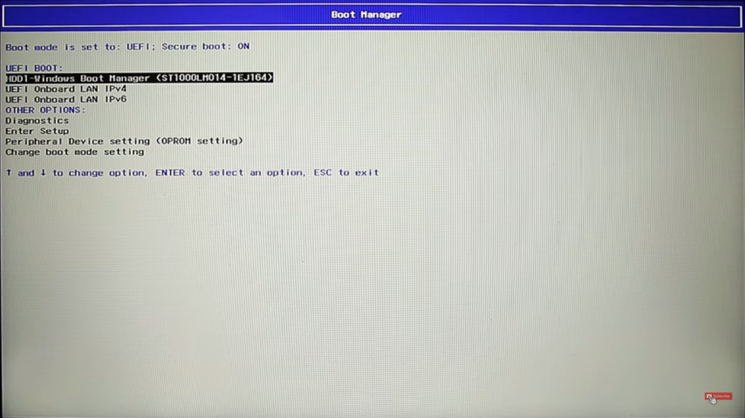
   3. F10 goes to BIOS settings in my HP laptop.
   4. Go to BIOS settings and change the **Secure Boot to disabled** and **Legacy Mode to Disabled**.
   5. Press F10 to save and exit.
   6. Restart computer.